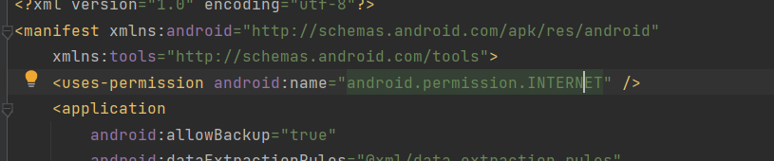

I started with adding the permissions to access the internet from the app

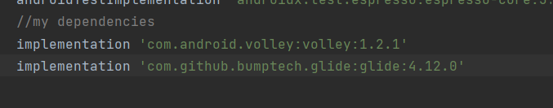

I also added the necessary API and glide dependencies to access and use data

I also added the objects to the layout to show the information

I used volley to access and get information from the API.

I created a JSON object with the data that was retrieved from the API and used it to get the individual parts needed for the app

